# Data and Visualization

Team 10: Jeevan Rai & Abhilash Narayanan

**Executive Summary:**

This report is on analyzing various aspects of social structures that were collected during the COVID-19 pandemic. These social structures are referred as variables for the dataset COVID-19_cases_plus_census that go through various data mining processes to discover any possible relationships with the number of cases and/or deaths for various geographic regions. There could be many possible reasons that could depict the observed confirmed cases and/or deaths for a particular region during the pandemic. Discovering such insightful relationships and building an effective predictive model are the two primary problems described in the report. From the general public to leaders of various government and non-government institutions, the information described in the report can be beneficial in many ways.

**Table of Contents**

1 Data and Visualization 1

2 Business Understanding 3

3 Data Preparation 3

3.1 K-means Clustering 4

3.2 K-means Clustering (Race & Income Ranges) 5

3.2.1 First K-means Clustering 6

3.2.2 Second K-means Clustering 6

3.2.3 Third K-means Clustering 7

3.2.4 Fourth K-means Clustering 8

4 Modeling 8

4.1 K-means Clustering 10

4.1.1 First k-means Clustering 10

4.1.2 Second k-means Clustering 14

4.1.3 Third k-means Clustering 18

4.1.4 Fourth k-means Clustering 18

4.2 Hierarchical Clustering 19

4.2.1 Identifying Linkage methods. 19

4.2.2 Dendrogram 20

4.2.3 Un Supervised Cluster Evaluation 21

4.2.4 Supervised Cluster evaluation. 23

4.2.5 Cluster visualizations 23

4.3 Density Based Clustering 26

4.3.1 Un-Supervised Cluster evaluation 27

4.3.2 Supervised Cluster evaluation 29

4.3.3 Cluster Visualizations 29

4.4 Fuzzy Clustering 29

3 Evaluation 29

3.1 K-means clustering 29

4 Conclusion 31

5 List of References 31

6 Appendix 31

# Business Understanding

A widespread disease COVID-19 (also known as coronavirus disease 2019) started at the end of 2019, and it quickly spread throughout the entire world impacting every aspect of human society. It was first identified in December 2019 in Wuhan district in China. Since then, there have been several kinds of studies conducted on the impact of this pandemic. The data on those studies are available for the general public. Among those datasets, we will be looking at four different datasets. The primary focus of the analysis is based on understanding the impact of this pandemic on various aspects of human society all around the world from 2019. These policies were primarily implemented to enforce “social distancing” amongst people. Social distancing involves measures taken to reduce close contact between individuals to slow the spread of infectious diseases such as COVID-19. By implementing measures like social distancing, mask-wearing, and hygiene practices, the goal is to spread out the number of cases over a longer period, resulting in a flatter curve. Additionally, data mining is performed on these datasets to understand any existing relationships between entities. This can be used to predict recurrence of similar pandemic in the near future and the consequences of such situations.

# Data Preparation

## K-means Clustering

|  |  |  |  |  |  |  |  |
| --- | --- | --- | --- | --- | --- | --- | --- |
| **Feature** | **Statistics** |  | **Feature** | **Statistics** |  | **Feature** | **Statistics** |
| county_name | Length:222  Class :character  Mode :character |  | white_pop | Min. : 55  1st Qu.: 2580  Median : 7632  Mean : 18563  3rd Qu.: 18465  Max. :162449 |  | female_0_20 | Min. : 4.0  1st Qu.: 771.5  Median : 1880.5  Mean : 6437.0  3rd Qu.: 4783.8  Max. :159914.0 |
| male_pop | Min. : 1  1st Qu.: 436  Median : 1077  Mean : 3619  3rd Qu.: 2544  Max. :107552 |  | black_pop | Min. : 0.00  1st Qu.: 55.25  Median : 482.50  Mean : 3292.94  3rd Qu.: 2673.00  Max. :85901.00 |  | female_21_49 | Min. : 8.0  1st Qu.: 898.5  Median : 2184.0  Mean : 7743.7  3rd Qu.: 5924.0  Max. :164411.0 |
| female_pop | Min. : 0.00  1st Qu.: 12.00  Median : 25.50  Mean : 77.73  3rd Qu.: 61.75  Max. :2018.00 |  | asian_pop | Min. : 0.0  1st Qu.: 6.0  Median : 45.0  Mean : 556.8  3rd Qu.: 241.8  Max. :12857.0 |  | female_50_above | Min. : 23  1st Qu.: 1184  Median : 3010  Mean : 7664  3rd Qu.: 7389  Max. :136600 |
| hispanic_pop | Min. : 12  1st Qu.: 1468  Median : 3700  Mean : 19338  3rd Qu.: 9827  Max. :770794 |  | amerindian_pop | Min. : 0.0  1st Qu.: 5.0  Median : 30.5  Mean : 125.9  3rd Qu.: 113.5  Max. :2344.0 |  | unemployed_pop | Min. : 0.0  1st Qu.: 121.2  Median : 382.0  Mean : 1197.7  3rd Qu.: 960.5  Max. :27566.0 |
| other_race_pop | Min. : 0.00  1st Qu.: 0.00  Median : 0.00  Mean : 31.38  3rd Qu.: 26.75  Max. :477.00 |  | median_income | Min. :24794  1st Qu.:41537  Median :46412  Mean :47428  3rd Qu.:52295  Max. :80938 |  | employed_pop | Min. : 39  1st Qu.: 2421  Median : 5354  Mean : 17677  3rd Qu.: 14372  Max. :341350 |
| income_less_50K | Min. : 9  1st Qu.: 1111  Median : 2740  Mean : 7589  3rd Qu.: 6524  Max. :148982 |  | income_50K_100K | Min. : 19.0  1st Qu.: 534.8  Median : 1427.5  Mean : 4176.5  3rd Qu.: 3627.0  Max. :74071.0 |  | commute | Min. : 66  1st Qu.: 4344  Median : 9925  Mean : 32754  3rd Qu.: 26827  Max. :647479 |
| income_100K_150K | Min. : 0.0  1st Qu.: 176.2  Median : 490.5  Mean : 1621.6  3rd Qu.: 1382.8  Max. :25925.0 |  | income_150K_more | Min. : 0.0  1st Qu.: 114.8  Median : 274.0  Mean : 984.0  3rd Qu.: 772.2  Max. :14222.0 |  | worked_at_home | Min. : 0.0  1st Qu.: 68.5  Median : 190.0  Mean : 598.5  3rd Qu.: 515.0  Max. :15026.0 |
| rent_under_50_percent | Min. : 7.0  1st Qu.: 289.5  Median : 820.0  Mean : 3317.0  3rd Qu.: 2171.0  Max. :73181.0 |  | rent_over_50_percent | Min. : 0.0  1st Qu.: 60.5  Median : 185.0  Mean : 1027.0  3rd Qu.: 599.0  Max. :19775.0 |  | walked_to_work | Min. : 0.0  1st Qu.: 47.0  Median : 101.5  Mean : 338.6  3rd Qu.: 242.2  Max. :6964.0 |
| median_age | Min. :25.80  1st Qu.:34.67  Median :39.20  Mean :39.31  3rd Qu.:43.27  Max. :57.50 |  | male_0_20 | Min. : 3  1st Qu.: 837  Median : 2079  Mean : 6785  3rd Qu.: 5274  Max. :163853 |  | male_21_49 | Min. : 10  1st Qu.: 971  Median : 2600  Mean : 8189  3rd Qu.: 6300  Max. :167493 |
|  |  |  | male_50_above | Min. : 29  1st Qu.: 1112  Median : 2830  Mean : 6771  3rd Qu.: 6769  Max. :109200 |  |  |  |

Statistics of dataset for k-means clustering

Shown above are all the features that are used to perform k-means clustering. The table also shows basic statistics of these features. Only the data points from Texas counties (excluding counties that belong to Dallas Fort Worth, Austin, San Antonio, and Houston) were selected for the dataset. These features were chosen in project 1 to understand possible correlations with COVID-19 confirmed and death cases.

## K-means Clustering (Race & Income Ranges)

|  |  |  |  |  |  |  |  |
| --- | --- | --- | --- | --- | --- | --- | --- |
| **Feature** | **Statistics** |  | **Feature** | **Statistics** |  | **Feature** | **Statistics** |
| white_pop | Min. :-0.642387  1st Qu.:-0.554748  Median :-0.379400  Mean : 0.000000  3rd Qu.:-0.003394  Max. : 4.994073 |  | black_pop | Min. :-0.36496  1st Qu.:-0.35884  Median :-0.31149  Mean : 0.00000  3rd Qu.:-0.06871  Max. : 9.15558 |  | asian_pop | Min. :-0.3314  1st Qu.:-0.3278  Median :-0.3046  Mean : 0.0000  3rd Qu.:-0.1875  Max. : 7.3199 |
| hispanic_pop | Min. :-0.2510  1st Qu.:-0.2321  Median :-0.2031  Mean : 0.0000  3rd Qu.:-0.1235  Max. : 9.7590 |  | amerindian_pop | Min. :-0.47791  1st Qu.:-0.45894  Median :-0.36216  Mean : 0.00000  3rd Qu.:-0.04717  Max. : 8.41787 |  | other_race_pop | Min. :-0.43877  1st Qu.:-0.43877  Median :-0.43877  Mean : 0.00000  3rd Qu.:-0.06472  Max. : 6.23116 |
| income_less_50K | Min. :-0.44296  1st Qu.:-0.37855  Median :-0.28334  Mean : 0.00000  3rd Qu.:-0.06225  Max. : 8.26280 |  | income_50K_100K | Min. :-0.48025  1st Qu.:-0.42067  Median :-0.31755  Mean : 0.00000  3rd Qu.:-0.06348  Max. : 8.07375 |  | income_100K_150K | Min. :-0.49239  1st Qu.:-0.43887  Median :-0.34345  Mean : 0.00000  3rd Qu.:-0.07254  Max. : 7.37936 |
| income_150K_more | Min. :-0.4780  1st Qu.:-0.4222  Median :-0.3449  Mean : 0.0000  3rd Qu.:-0.1028  Max. : 6.4301 |  |  |  |  |  |  |

Shown above are the features related to various races and income ranges that were used to perform k-means clustering. The objects that were chosen to cluster were the counties in Texas (excluding counties that belong to DFW metropolitan, Austin, San Antonio, and Houston). Each county is represented by a row, and the clustering is based on features including the number of people in various racial groups and income ranges. These features were chosen because we are interested in understanding the clustering of people living in Texas counties based on their racial demographics and income levels. By clustering based on these features, we aim to identify patterns and groupings that can provide insights into the socio-economic and racial composition of different regions within these counties. This can help in policy making, resource allocation, and understanding demographic trends.

The dataset was scaled to ensure that all of the datapoints lie within similar range. All of the features are on ratio scale because they represent counts of people from various counties that fall under these features. Since we are using k-means clustering, we are using Euclidean distance for similarity/distance. This method was chosen because it tends to work well with a centroid-based approach (i.e. k-means clustering).

### First K-means Clustering

|  |  |  |  |  |  |  |  |
| --- | --- | --- | --- | --- | --- | --- | --- |
| **Feature** | **Statistics** |  | **Feature** | **Statistics** |  | **Feature** | **Statistics** |
| white_pop | Min. :-0.642387  1st Qu.:-0.554748  Median :-0.379400  Mean : 0.000000  3rd Qu.:-0.003394  Max. : 4.994073 |  | income_100K_150K | Min. :-0.49239  1st Qu.:-0.43887  Median :-0.34345  Mean : 0.00000  3rd Qu.:-0.07254  Max. : 7.37936 |  | rent_under_50_percent | Min. :-0.4068  1st Qu.:-0.3720  Median :-0.3069  Mean : 0.0000  3rd Qu.:-0.1408  Max. : 8.5854 |
| male_21_49 | Min. :-0.42670  1st Qu.:-0.37657  Median :-0.29161  Mean : 0.00000  3rd Qu.:-0.09854  Max. : 8.31051 |  | commute | Min. :-0.4412  1st Qu.:-0.3834  Median :-0.3081  Mean : 0.0000  3rd Qu.:-0.0800  Max. : 8.2967 |  |  |  |

Shown above are the features related to population of Hispanic men aged 21-49 making 100-150K, commuted to work, and spent more than 50% on rent. These are the features selected to perform first k-means clustering. The objects that were chosen to cluster were the counties in Texas (excluding counties that belong to DFW metropolitan, Austin, San Antonio, and Houston). We want to under the demographic of population that falls under these attributes.

The dataset was scaled to ensure that all of the datapoints lie within similar range. All of the features are on ratio scale because they represent counts of people from various counties that fall under these features. Since we are using k-means clustering, we are using Euclidean distance for similarity/distance. This method was chosen because it tends to work well with a centroid-based approach (i.e. k-means clustering).

### Second K-means Clustering

|  |  |  |  |  |  |  |  |
| --- | --- | --- | --- | --- | --- | --- | --- |
| **Feature** | **Statistics** |  | **Feature** | **Statistics** |  | **Feature** | **Statistics** |
| hispanic_pop | Min. :-0.2510  1st Qu.:-0.2321  Median :-0.2031  Mean : 0.0000  3rd Qu.:-0.1235  Max. : 9.7590 |  | income_50K_100K | Min. :-0.48025  1st Qu.:-0.42067  Median :-0.31755  Mean : 0.00000  3rd Qu.:-0.06348  Max. : 8.07375 |  | female_21_49 | Min. :-0.40366  1st Qu.:-0.35719  Median :-0.29011  Mean : 0.00000  3rd Qu.:-0.09495  Max. : 8.17512 |
| worked_at_home | Min. :-0.40128  1st Qu.:-0.35535  Median :-0.27388  Mean : 0.00000  3rd Qu.:-0.05596  Max. : 9.67399 |  |  |  |  |  |  |

Shown above are the features related to population of Hispanic women aged 21-49 making 50-100K and worked from home. These are the features selected to perform second k-means clustering. The objects that were chosen to cluster were the counties in Texas (excluding counties that belong to DFW metropolitan, Austin, San Antonio, and Houston). We want to under the demographic of population that falls under these attributes.

The dataset was scaled to ensure that all of the datapoints lie within similar range. All of the features are on ratio scale because they represent counts of people from various counties that fall under these features. Since we are using k-means clustering, we are using Euclidean distance for similarity/distance. This method was chosen because it tends to work well with a centroid-based approach (i.e. k-means clustering).

### Third K-means Clustering

|  |  |  |  |  |  |  |  |
| --- | --- | --- | --- | --- | --- | --- | --- |
| **Feature** | **Statistics** |  | **Feature** | **Statistics** |  | **Feature** | **Statistics** |
| income_100K_150K | Min. :-0.49239  1st Qu.:-0.43887  Median :-0.34345  Mean : 0.00000  3rd Qu.:-0.07254  Max. : 7.37936 |  | rent_under_50_percent | Min. :-0.4068  1st Qu.:-0.3720  Median :-0.3069  Mean : 0.0000  3rd Qu.:-0.1408  Max. : 8.5854 |  | male_50_above | Min. :-0.524613  1st Qu.:-0.440329  Median :-0.306636  Mean : 0.000000  3rd Qu.:-0.000192  Max. : 7.969696 |
| commute | Min. :-0.4412  1st Qu.:-0.3834  Median :-0.3081  Mean : 0.0000  3rd Qu.:-0.0800  Max. : 8.2967 |  |  |  |  |  |  |

Shown above are the features related to population of men aged over 50 making more than 100K, spent less than 50% on rent, and commuted to work These are the features selected to perform second k-means clustering. The objects that were chosen to cluster were the counties in Texas (excluding counties that belong to DFW metropolitan, Austin, San Antonio, and Houston). We want to under the demographic of population that falls under these attributes.

The dataset was scaled to ensure that all of the datapoints lie within similar range. All of the features are on ratio scale because they represent counts of people from various counties that fall under these features. Since we are using k-means clustering, we are using Euclidean distance for similarity/distance. This method was chosen because it tends to work well with a centroid-based approach (i.e. k-means clustering).

### Fourth K-means Clustering

|  |  |  |  |  |  |  |  |
| --- | --- | --- | --- | --- | --- | --- | --- |
| **Feature** | **Statistics** |  | **Feature** | **Statistics** |  | **Feature** | **Statistics** |
| hispanic_pop | Min. :-0.2510  1st Qu.:-0.2321  Median :-0.2031  Mean : 0.0000  3rd Qu.:-0.1235  Max. : 9.7590 |  | income_50K_100K | Min. :-0.48025  1st Qu.:-0.42067  Median :-0.31755  Mean : 0.00000  3rd Qu.:-0.06348  Max. : 8.07375 |  | male_21_49 | Min. :-0.42670  1st Qu.:-0.37657  Median :-0.29161  Mean : 0.00000  3rd Qu.:-0.09854  Max. : 8.31051 |
| commute | Min. :-0.4412  1st Qu.:-0.3834  Median :-0.3081  Mean : 0.0000  3rd Qu.:-0.0800  Max. : 8.2967 |  | rent_over_50_percent | Min. :-0.3775  1st Qu.:-0.3553  Median :-0.3095  Mean : 0.0000  3rd Qu.:-0.1573  Max. : 6.8913 |  |  |  |

Shown above are the features related to population of Hispanic men aged 21-49 making 50-100K, spent more than 50% on rent, and commuted to work These are the features selected to perform second k-means clustering. The objects that were chosen to cluster were the counties in Texas (excluding counties that belong to DFW metropolitan, Austin, San Antonio, and Houston). We want to under the demographic of population that falls under these attributes.

The dataset was scaled to ensure that all of the datapoints lie within similar range. All of the features are on ratio scale because they represent counts of people from various counties that fall under these features. Since we are using k-means clustering, we are using Euclidean distance for similarity/distance. This method was chosen because it tends to work well with a centroid-based approach (i.e. k-means clustering).

# Modeling

| **Clustering** | **Features Selected** | **Unsupervised**  **Evaluation** | **Supervised Evaluation** | **Similarity/Distance method** |
| --- | --- | --- | --- | --- |
| k-means clustering (first clustering) | white_pop, income_100K_150K, rent_under_50_percent, male_21_49, commute | Average Silhouette Width  Dunn Index  Pearson gamma  Within cluster sum of squares Elbow Method Gap Statistic | Purity  Entropy | Euclidean distance |
| k-means clustering (second clustering) | * hispanic_pop * income_50K_100K * female_21_49 * worked_at_home | * Average Silhouette Width * Dunn Index * Pearson gamma * Within cluster sum of squares Elbow Method Gap Statistic | Purity  Entropy | Euclidean distance |
| k-means clustering (third clustering) | * income_100K_150K * rent_under_50_percent * male_50_above * commute | * Average Silhouette Width * Dunn Index * Pearson gamma * Within cluster sum of squares Elbow Method Gap Statistic | Purity  Entropy | Euclidean distance |
| k-means clustering (fourth clustering) | * hispanic_pop, * income_50K_100K * male_21_49 * commute * rent_over_50_percent | * Average Silhouette Width * Dunn Index * Pearson gamma * Within cluster sum of squares Elbow Method Gap Statistic | Purity  Entropy | Euclidean distance |
| Hierarchical Clustering  (4 clusters with cluster numbers 2,4,6,8) | * median_income * median_age * commute_1000 * black_pop * white_pop * hispanic_pop | * Gap Statistic * Average Silhouette Width | Purity | Wards minimum variance method |
| Density Based Clustering | * income_100K_150K * commute_1000 * worked_at_home_1000 | * Dunn Index * Average Silhouette Width | Purity | Euclidean distance |
| Fuzzy Clustering | * median_age * commute_1000 * median_income | * Davies-Bouldin index |  |  |

## K-means Clustering

### First k-means Clustering

Before performing k-means clustering with certain number of clusters, we calculated the Hopkins statistic. The value was 0.99 which is close to 1 indicating that the dataset had a strong clustering tendency. Additionally, we also created following plots to visualize distance matrix of the dataset. It’s a heatmap of the distances between observations in the dataset. These plots help us to understand the structure of the data which helps us to identify any natural groupings or patterns in the dataset. This gives us a round idea of how many clusters might be appropriate based on the distributions of the distances. Based on the factoextra plot, we can say that we might need 3 clusters in the k-means clustering for this dataset.

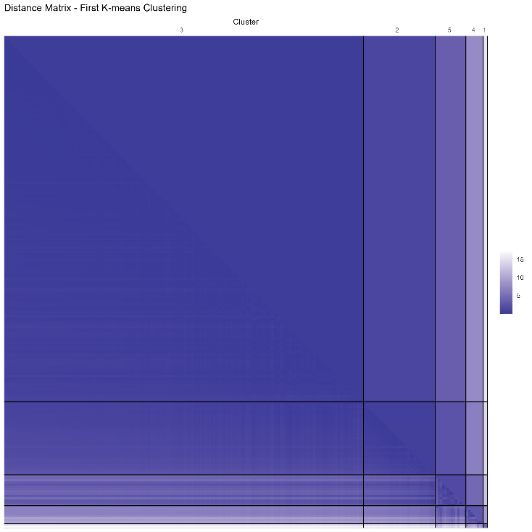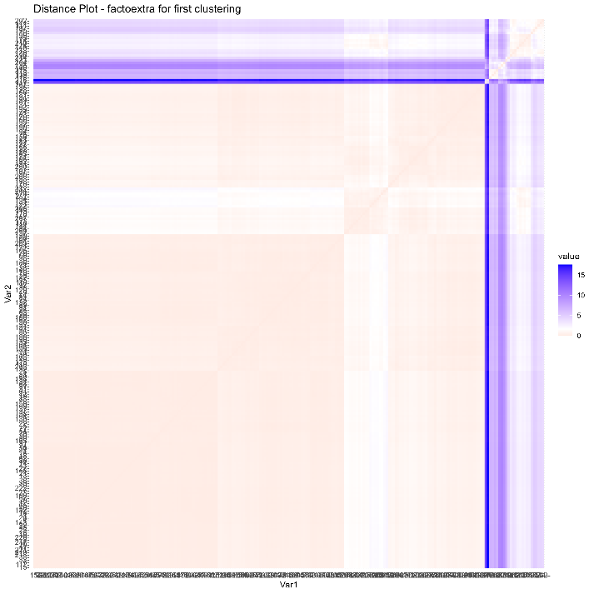

Fig. Distance matrix (left) and factoextra plot (right) for first clustering

**Determine suitable number of clusters**

**Average Silhouette Width**

To determine suitable number of clusters for the dataset, we started with analyzing the average silhouette width for various number of clusters. Based on the plot below, we can see that the highest value is at 2 clusters, and the value starts to decrease rapidly with a greater number of clusters. Thus, based on this assessment, we just need 2 clusters for the dataset.

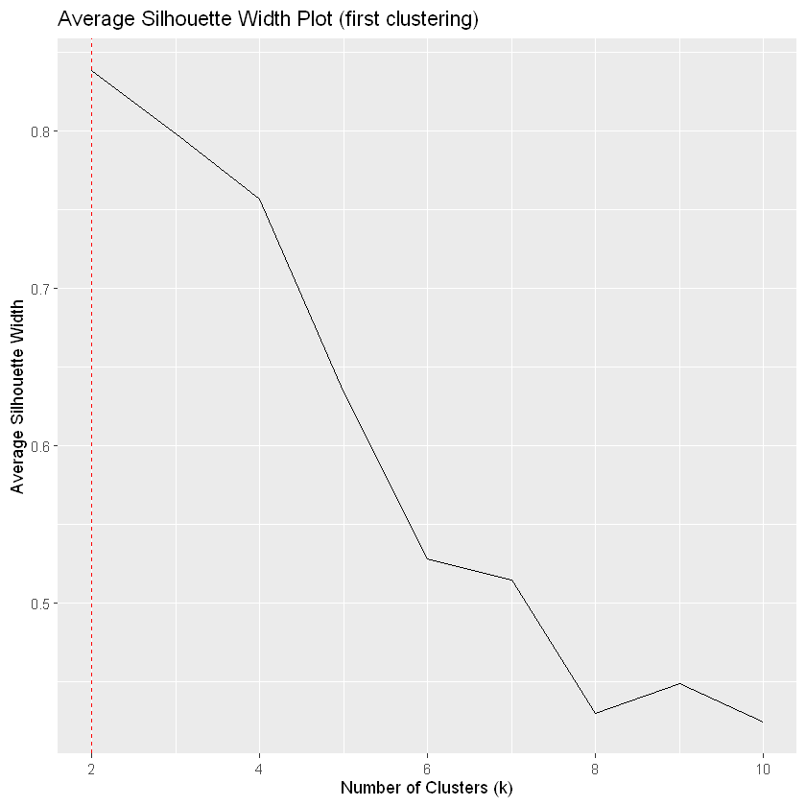

Fig. Average silhouette width plot for first clustering

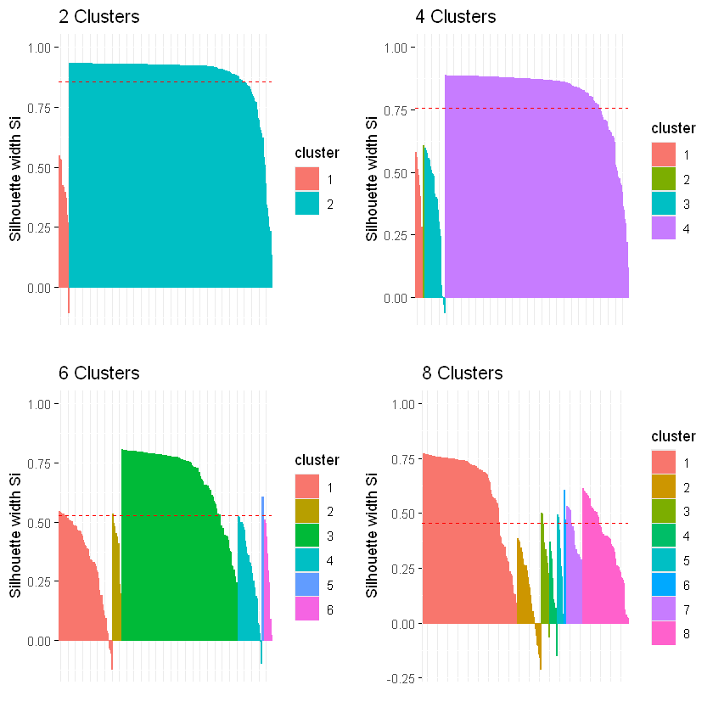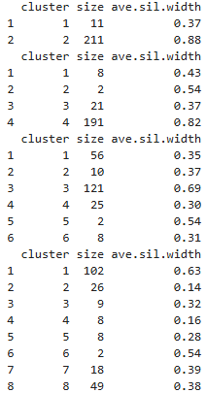

Fig. Silhouette plots for various number of clusters for first clustering

Next, we look at analyzing the silhouette widths and plots for various number of clusters. Based on the above plot, 4 clusters appear to be promising, with two clusters having reasonably high silhouette widths (0.54 and 0.82), but the other two clusters have lower silhouette widths, reducing the overall quality of clustering. Also, the first and second clusters have very few datapoints. 2 Clusters seems to be the optimal choice as it has one cluster with a very high silhouette width (0.88). Although the other cluster has a lower silhouette width (0.37), the simplicity of having fewer

clusters often provide more meaningful insights without overcomplicating the interpretation.

**Elbow Method: Within-Cluster Sum of Square**

Next, we used the Elbow method to visually identify the optimum number of clusters. Based on the elbow plot below, we can see that the within sum of squares value starts to decrease not so significantly after 5 clusters. Since the elbow point (or knee) indicates a point where adding more clusters does not significantly improve the compactness of the clusters, suggesting that the optimal number of clusters has been reached, we can say that the optimum number of clusters is 5.

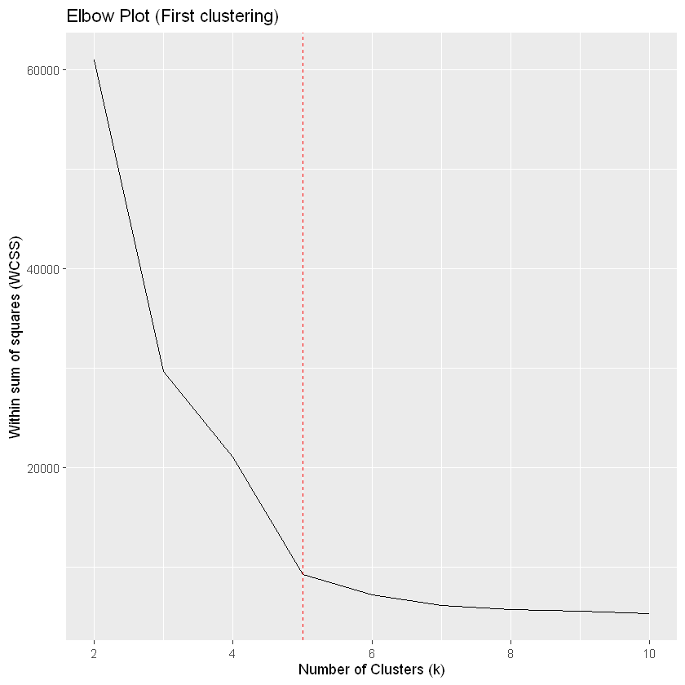

Fig. Elbow plot for first clustering

**Gap Statistic**

Next, we used gap statistic method to find optimum number of clusters. It compares the total within-cluster variation for different numbers of clusters with their expected values under null reference distributions of the data. Based on the plot below, we can see that the max gap value is 1.766 at 10 clusters. The standard error of the maximum (k=10) is 0.0164. So threshold is 1.75 (i.e. 1.766 – 0.0164). This means that the gap value 1.766 is within one standard error (i.e. higher than the threshold). Thus, based on this assessment, the optimum number of clusters is 10.

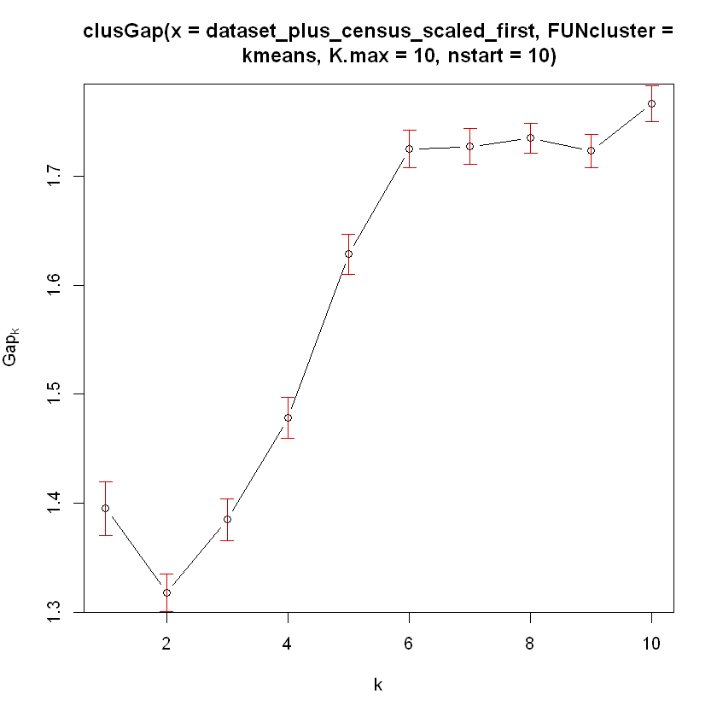 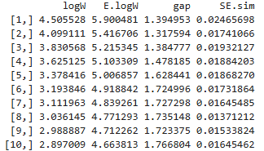

Fig. Gap statistic for first clustering

**Supervised Evaluation**

Next, we computed various metrics for different number of clusters as shown below. Looking at the sum of squares, we see that the value starts to decrease not so significantly after 5 clusters supporting the observation made on elbow method. Looking at the average silhouette width, we can see that it is max at 2 clusters. The pearson gamma values also indicate that the optimum number of clusters is 2. The dunn index also indicates that 2 clusters are needed. While increasing the number of clusters reduces the within-cluster sum of squares, it also leads to a decrease in the average silhouette width, pearson gamma, and dunn index, indicating lower clustering quality. Thus, we can finally say that the optimum number clusters for the dataset is 2.

|  |  |  |  |  |
| --- | --- | --- | --- | --- |
| **Metric** | **2 clusters** | **3 clusters** | **5 clusters** | **6 clusters** |
| within.cluster.ss | 397.8061 | 215.1592 | 82.48649 | 71.37958 |
| avg.silwidth | 0.838251 | 0.798405 | 0.633407 | 0.52843 |
| pearsongamma | 0.806838 | 0.771368 | 0.560038 | 0.399343 |
| dunn | 0.042062 | 0.035202 | 0.024113 | 0.014214 |

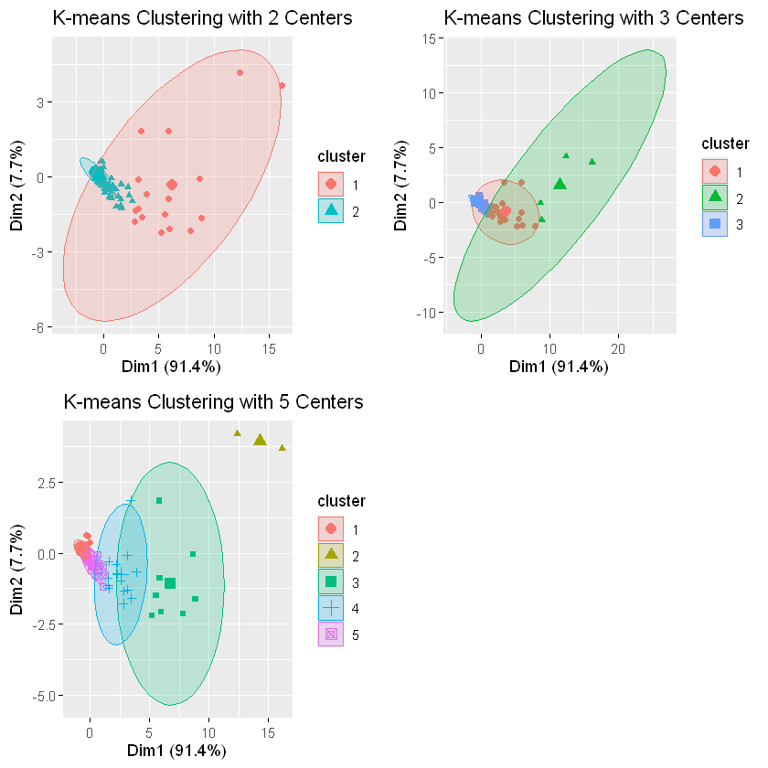 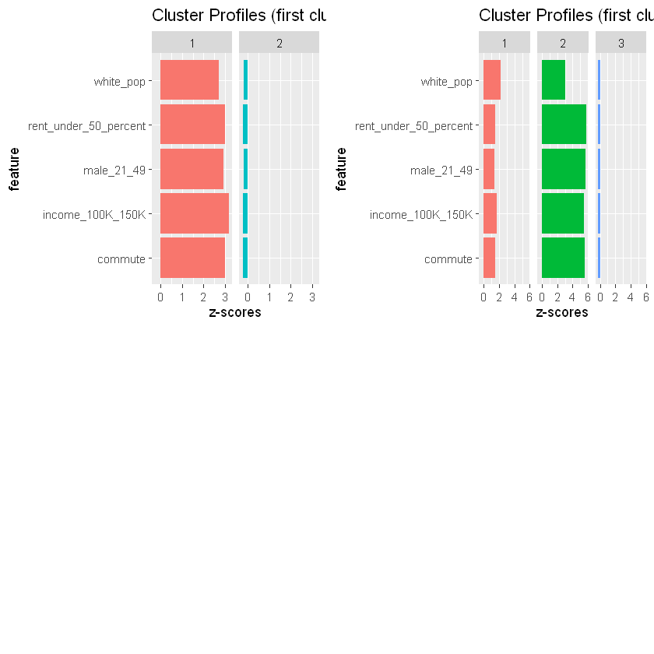

Fig. Visualization for first clustering

To further validate the above conclusion, we used visualization of the clustering as shown above. Looking at the clusters on the left, we can see that we only need two clusters. When an additional cluster is added, the clusters don’t properly represent the datapoints. Some of the datapoints that belong to cluster 1 can also be part of cluster 3. Similarly, looking at the plot on the right, we can see that the third cluster has almost same distribution for all the features indicating that it does identify any significant variance of the dataset. It also supports that there are only 2 clusters needed for this dataset. Therefore, based on all of the assessments, we can say that 2 is the optimum number of clusters for the dataset.

### Second k-means Clustering

Before performing k-means clustering with certain number of clusters, we calculated the Hopkins statistic. The value was 0.99 which is close to 1 indicating that the dataset had a strong clustering tendency. Additionally, we also created following plots to visualize distance matrix of the dataset. Based on the factoextra plot, we can say that we might need 2 clusters in the k-means clustering for this dataset.

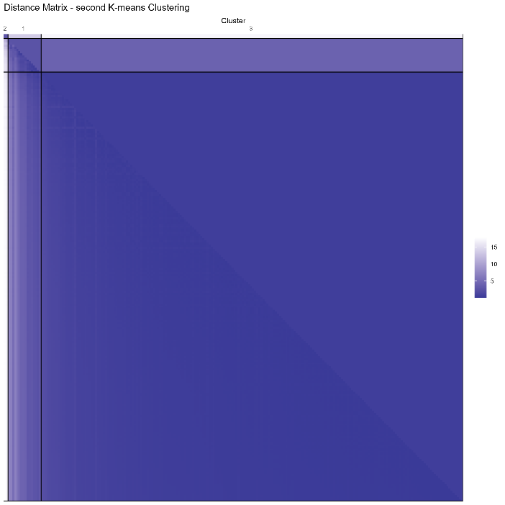 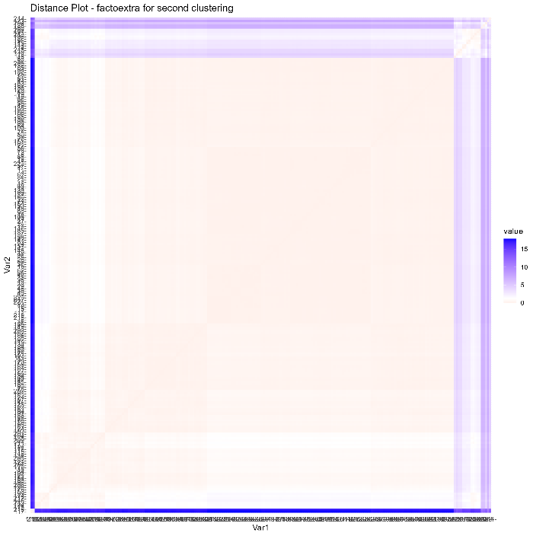

Fig. Distance matrix (left) and factoextra plot (right) for second clustering

**Determine suitable number of clusters**

**Average Silhouette Width**

To determine suitable number of clusters for the dataset, we started with analyzing the average silhouette width for various number of clusters. Based on the plot below, we can see that the highest value is at 2 clusters, and the value starts to decrease rapidly with a greater number of clusters. Thus, based on this assessment, we just need 2 clusters for the dataset.

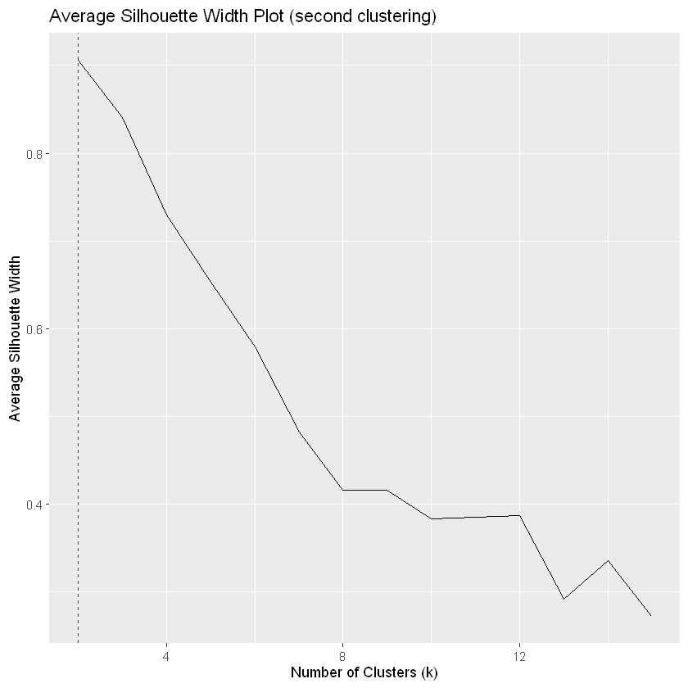

Fig. Average silhouette width plot for first clustering

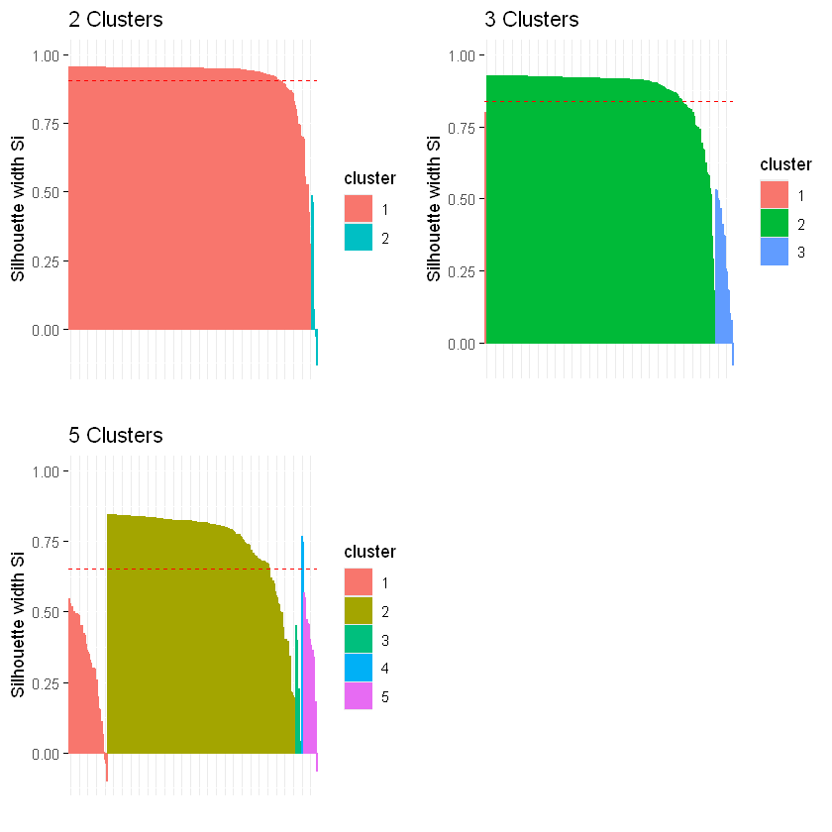 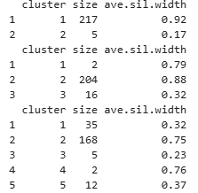

Fig. Silhouette plots for various number of clusters for second clustering

Next, we look at analyzing the silhouette widths and plots for various number of clusters. Considering both the

silhouette width and the distribution of cluster sizes, the clustering with 2 clusters seems to be the most appropriate

choice. Cluster 1 has a very high silhouette width (0.92), indicating well-separated clusters. While Cluster 2 is small,

the overall simplicity and high silhouette width for the main cluster make this a reasonable choice.

**Elbow Method: Within-Cluster Sum of Square**

Next, we used the Elbow method to visually identify the optimum number of clusters. Based on the elbow plot below, we can see that the within sum of squares value starts to decrease not so significantly after about 7 clusters. Since the elbow point (or knee) indicates a point where adding more clusters does not significantly improve the compactness of the clusters, suggesting that the optimal number of clusters has been reached, we can say that the optimum number of clusters is 7.

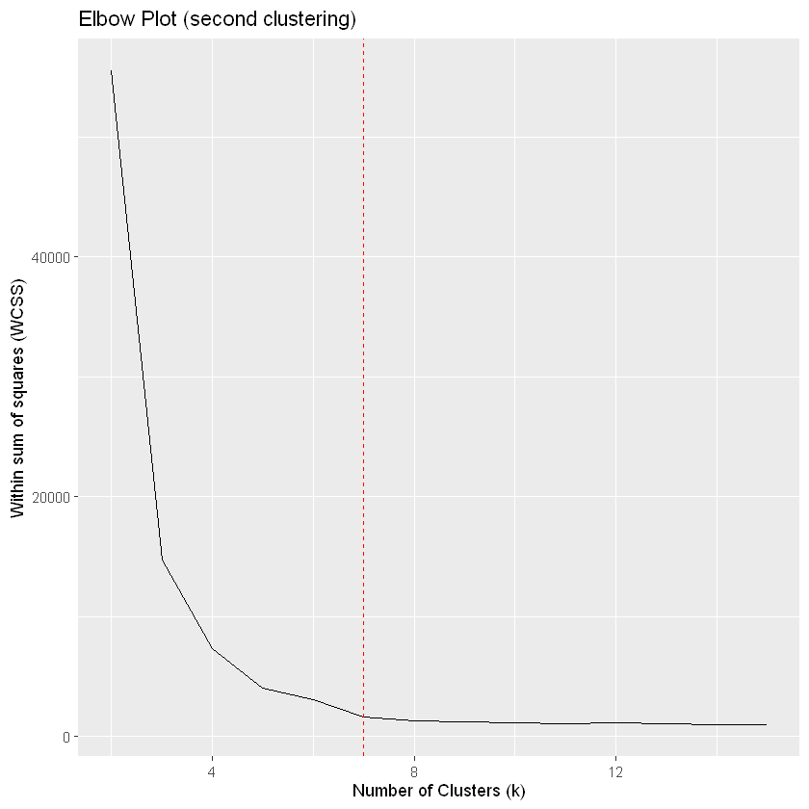

Fig. Elbow plot for first clustering

**Gap Statistic**

Next, we used gap statistic method to find optimum number of clusters. Based on the plot below, we can see that the max gap value is 2.07 at 10 clusters. The standard error of the maximum (k=10) is 0.017. So threshold is. 2.05 (i.e. 2.07 – 0.017). This means that the gap value 2.07 is within one standard error (i.e. higher than the threshold). Thus, based on this assessment, the optimum number of clusters is 10.

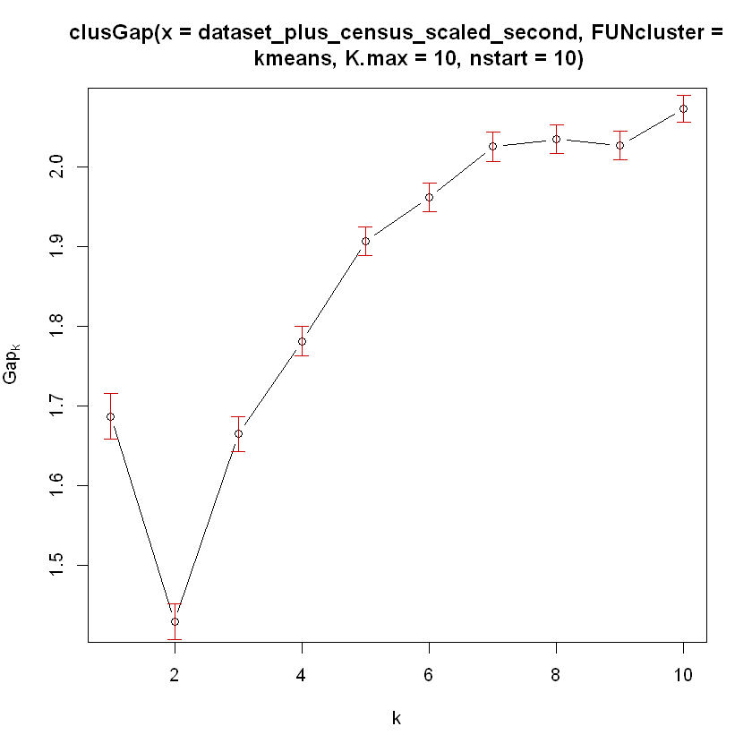 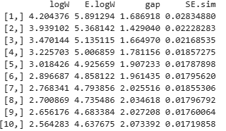

Fig. Gap statistic for first clustering

**Supervised Evaluation**

Next, we computed various metrics for different number of clusters as shown below. All of the of the metrics are the highest for 2 clusters indicating that the optimum number of clusters is 2 for this dataset.

|  |  |  |  |  |
| --- | --- | --- | --- | --- |
| **Metric** | **2 clusters** | **3 clusters** | **4 clusters** | **6 clusters** |
| within.cluster.ss | 336.9456 | 103.8761 | 64.20614 | 38.06195 |
| avg.silwidth | 0.9055904 | 0.8404076 | 0.729722 | 0.579127 |
| pearsongamma | 0.8086453 | 0.7104225 | 0.5720946 | 0.4022496 |
| dunn | 0.1275271 | 0.07974147 | 0.03998538 | 0.01211304 |

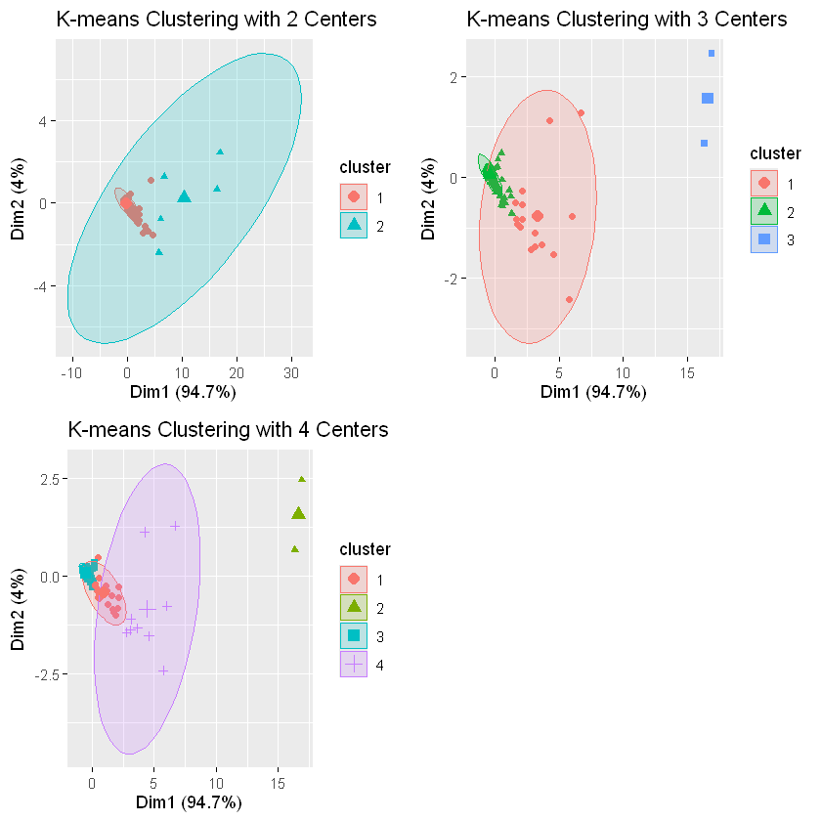 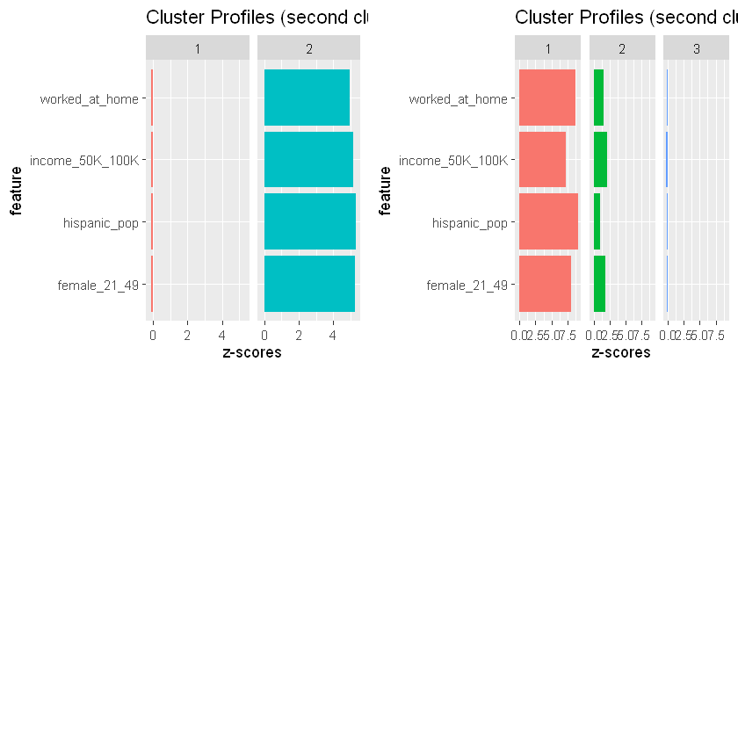

Fig. Visualization for first clustering

To further validate the above conclusion, we used visualization of the clustering as shown above. Looking at the clusters on the left, we can see that we only need two clusters. When an additional cluster is added, the clusters don’t properly represent the datapoints. The third cluster seems to cluster outliers. Similarly, looking at the plot on the right, we can see that the third cluster has almost same distribution for all the features indicating that it does identify any significant variance of the dataset. It also supports that there are only 2 clusters needed for this dataset. Therefore, based on all of the assessments, we can say that 2 is the optimum number of clusters for the dataset.

### Third k-means Clustering

### Fourth k-means Clustering

**Supervised Evaluation (Compare all four k-means clusterings)**

Statement

## Hierarchical Clustering

Hierarchical clustering is an alternative approach to for identifying groups in the dataset. It does not require us to pre-specify the number of clusters to be generated. Furthermore, hierarchical clustering has an added advantage that it results in an attractive tree-based representation of the observations, called a dendrogram.

### Identifying Linkage methods.

Agglomerative coefficient of the below methods was calculated and the best method was chosen. The below table shows these methods and the corresponding coefficient for this dataset

| **Linkage Method** | **Description** | **Agglomerative coefficient for this dataset** |
| --- | --- | --- |
| Complete linkage clustering: | It computes all pairwise dissimilarities between the elements in cluster 1 and the elements in cluster 2, and considers the largest value (i.e., maximum value) of these dissimilarities as the distance between the two clusters. It tends to produce more compact clusters. | 0.9422264 |
| Single linkage clustering | computes all pairwise dissimilarities between the elements in cluster 1 and the elements in cluster 2, and considers the smallest of these dissimilarities as a linkage criterion. It tends to produce long, “loose” clusters. | 0.8757889 |
| Mean or average linkage clustering: | It computes all pairwise dissimilarities between the elements in cluster 1 and the elements in cluster 2, and considers the average of these dissimilarities as the distance between the two clusters. | 0.9272677 |
| Ward’s minimum variance method: | It minimizes the total within-cluster variance. At each step the pair of clusters with minimum between-cluster distance are merged. | 0.9702966 |

Based on the Agglomerative Coefficient results, the maximum coefficient was for the Wards minimum variance method that the same is used for the clustering.

### Dendrogram

Below is the dendrogram which shows the hierarchical clustering results.

We will be evaluating the clusters with number of cluster 2,4,6,8

### Un Supervised Cluster Evaluation

The Cluster Gap Analysis showed two cluster are the most optimal clustering:

To confirm this analysis, We create clustering with 2,4,6, and 8 number of clusters and compared all these clusters based on Silhouette Coefficient. Below table shows the Silhouette coefficient for these clusters.

The highest Silhouette coefficient is for the Cluster with number of clusters = 2.

Hence, we conclude that number of cluster = 2 is the most optimal clustering for the features that were selected.

### Supervised Cluster evaluation.

The ground truth that was selected to evaluate the cluer was a quintile of death percentage, where the first 10% is consided as High and the next 90% is considered as Low

Below snippet shows the selected ground truth

ground_truth

1 2

192 30

Purity measure was used to compare the Cluster with the ground tructh. Below snippet shows the result of this comparison.

**$pur**

**0.725225225225225**

**$out**

| A data.frame: 1 × 3 | | | |
| --- | --- | --- | --- |
|  | **ClassLabels** | **ClusterLabels** | **ClusterSize** |
|  | **<chr>** | **<chr>** | **<dbl>** |
| **1** | 2 | 1 | 161 |

### Cluster visualizations

From this Diagram, We can see that that the clusters can be easily istinguesd based on the feature that were selected.

Also, the below are the counties look based on how that is plotted in a Texas Map.

The below table shows the average values of the features for the two clusters.

|  |  |  |  |  |  |  |  |  |  |  |  |  |  |  |  |  |  |  |  |  |  |  |  |  |  |  |  |
| --- | --- | --- | --- | --- | --- | --- | --- | --- | --- | --- | --- | --- | --- | --- | --- | --- | --- | --- | --- | --- | --- | --- | --- | --- | --- | --- | --- |
| |  |  |  | | --- | --- | --- | | **Cluster** | **1** | **2** | | avg_death_per_case | 0.01952826 | 0.02737668 | | avg_median_age | 34.04194 | 40.16073 | | avg_median_income | 49015.00 | 47170.13 | | avg_commute_1000 | 799.9042 | 738.8050 | | avg_black_pop_1000 | 110.36313 | 50.63811 | | avg_white_pop_1000 | 519.8909 | 571.7030 | | avg_hispanic_pop_1000 | 331.7475 | 355.7910 | | no_counties_in_cluster_1000 | 31 | 191 | |

From this table, We can identify that the cluster 1 has a higher average median income and a lesser death per case. From this we can identify that COVID deaths affected the counties with lesser median income

## Density Based Clustering

Selecting the min and eps

The Knee of the distance is between 0.5 to 1. Hence we will be selecting EPS between these for 2 cluster evaluations

### Un-Supervised Cluster evaluation

Below diagram shows the Silhoutte coefficient of the two clusters.

As described in the diagram Silhoutte distance is 0.39 for both clusters. Hence another evaluation method called Dunn Index is used to evaluate the clusters

|  |  |
| --- | --- |
| **Cluster Number** | **Dunn Index** |
| 1 | 0.200692885450029 |
| 2 | 0.192685680236223 |

With Dunn Index, We can identify that the Cluster 1 is a better cluster with Higher Dunn Index

### Supervised Cluster evaluation

### Cluster Visualizations

## Fuzzy Clustering

# Evaluation

### K-means clustering

**First K-means Clustering**

After establishing optimum number of clusters, we generated a heat map of Texas showing all the counties that belonged to one of the two clusters. There are 16 counties that belong to cluster 1, and the name of those counties are shown below. Most of these counties lie far away from the major cities like DFW, Austin, San Antonio, and Houston. We can also see that these counties had higher average confirmed cases per 1000 than the counties that belong to cluster 2. But surprisingly, these counties had lower average deaths per 1000 than those that belong to cluster 2. This could mean that the counties in cluster 1 more confirmed cases but there were effective interventions or better healthcare that kept the mortality rate lower. On the contrary, the counties in cluster 2 could have been less equipped to manage the severity of the virus, or other factors which contributed to higher death rate.

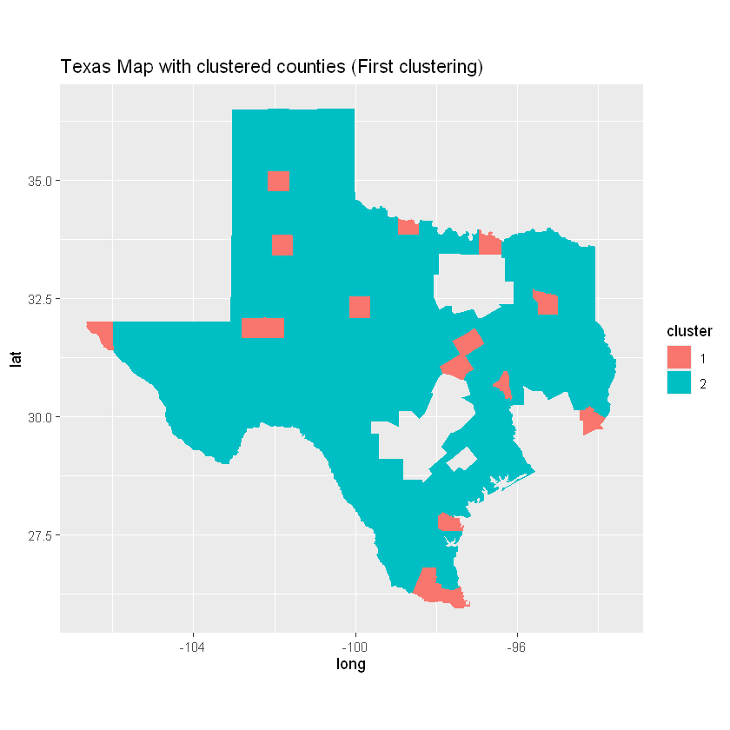 

|  |  |  |
| --- | --- | --- |
| cluster | avg_cases_per_1000 | avg_deaths_per_1000 |
| 1 | 88.22725 | 1.657642 |
| 2 | 78.07511 | 2.009892 |

Fig. Clusters of counties for first clustering

**Second K-means Clustering**

After establishing optimum number of clusters, we generated a heat map of Texas showing all the counties that belonged to one of the two clusters. There are 5 counties that belong to cluster 1, and the name of those counties are shown below. Most of these counties lie far away at the edges of the state. We can also see that these counties had higher average confirmed cases per 1000 than the counties that belong to cluster 2. Additionally, these counties also had higher average deaths per 1000 than those that belong to cluster 2. This could mean that the counties in cluster 2 had less equipped to manage the severity of the virus, or other factors contributing to higher confirmed and death rates.

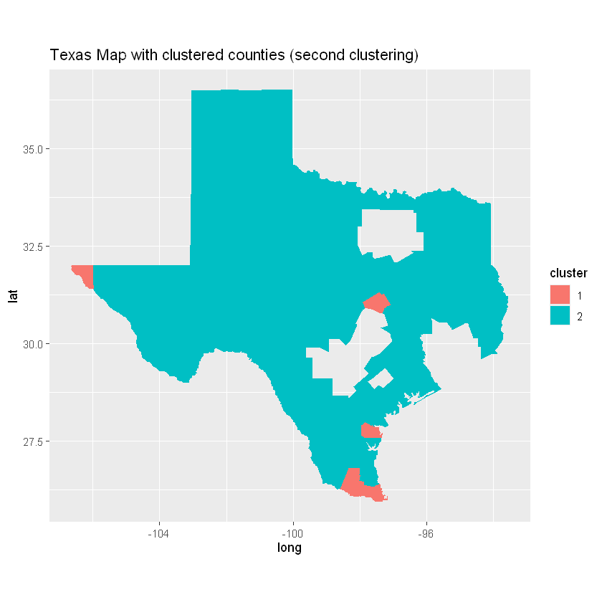



|  |  |  |
| --- | --- | --- |
| cluster | avg_cases_per_1000 | avg_deaths_per_1000 |
| 1 | 98.03851 | 2.363770 |
| 2 | 78.63196 | 1.981056 |

Fig. Clusters of counties for second clustering

# Conclusion

[Does the project answer the initial questions? Repeat the key findings and why they are important.]

# List of References

USAFacts. (n.d.). COVID-19 case and death counts by state and county. In USAFacts Public Data - COVID-19 US Cases. Retrieved from

<https://console.cloud.google.com/bigquery?p=bigquery-public-data&d=covid19_usafacts&page=dataset&project=crucial-cycling-338005&ws=!1m4!1m3!3m2!1sbigquery-public-data!2scovid19_usafacts>

# Appendix